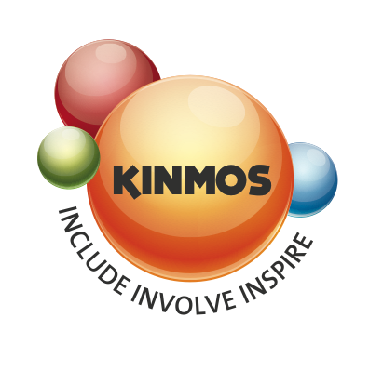

**Gift Aid Declaration**

**Name of charity or CASC: KINMOS VOLUNTEER GROUP LTD**

**REGISTERED CHARITY NUMBER. 519738**

**Please treat**

* The enclosed gift of £ ----------------------------- as a Gift Aid donation; **OR**
* All gifts of money that I make today and in the future as Gift Aid donations; **OR**
* All gifts of money that I have made in the past 4 years and all future gifts of money that I make from the date of this declaration as Gift Aid donations.

(Please tick the appropriate box)

You must pay an amount of Income Tax and/or Capital Gains Tax for each tax year (6 April one year to 5 April the next) that is at least equal to the amount of tax that the charity or Community Amateur Sports Club will reclaim on your gifts for that tax year.

**Donor’s details**

Title ----------------- Initial(s) ---------------- Surname -----------------------------------------------------------------

Home address --------------------------------------------------------------------------------------------------------------

----------------------------------------------------------------------------------------------------------------------------------

-----------------------------------------------------------------------------------------Postcode ----------------------------

Signature ---------------------------------------------------------------------------Date-----------------------------------

Please return this form to

Kinmos,

149-153 Alcester Road,

Moseley,

Birmingham,

B13 8JP.

**Please notify the charity or CASC if you:**

* Want to cancel this declaration
* Change your name or home address
* No longer pay sufficient tax on your income and/or capital gains.

**Tax claimed by the charity or CASC**

The charity or CASC will reclaim 28p of tax on every £1 you gave up to 5 April 2008.

The charity or CASC will reclaim 25p of tax on every £1 you give on or after 6 April 2008.

The Government will pay to the charity or CASC an additional 3p on every £1 you give between 6 April 2008 and 5 April 2011.

This transitional relief for the charity or CASC does not affect your personal tax position. If you pay Income Tax at the higher rate, you must include all your Gift Aid donations on your Self-Assessment tax return if you want to receive the additional tax relief due to you.